EXP NO: 4
Web Form with Servlet to Capture and Display User's Name and Age

AIM:
Create a web form that accepts a user's name and age. Write a Servlet to process the form data and display it back on the browser.

CODE:
Userdetails.html
<!DOCTYPE html>
<html>
<head>
<meta charset="ISO-8859-1">
<title>Insert title here</title>
</head>
<body>
<form action="./UserValidate">
<label for="name">User Name</label>
<input type="text" id="name" name="name" placeholder="Enter Your Name" required><br><br>

<label for="age">Age</label>
<input type="number" id="age" name="age" placeholder="Enter Your Age"><br><br>

<button type="submit">Submit</button>
</form>
</body>
</html>

UserValidate.Java
package com.karthick.servlet;

import java.io.IOException;
import java.io.PrintWriter;

import javax.servlet.ServletException;
import javax.servlet.annotation.WebServlet;
import javax.servlet.http.HttpServlet;
import javax.servlet.http.HttpServletRequest;
import javax.servlet.http.HttpServletResponse;

/**
* Servlet implementation class UserValidate
*/
@WebServlet("/UserValidate")
public class UserValidate extends HttpServlet {
private static final long serialVersionUID = 1L;

/**
* @see HttpServlet#HttpServlet()
*/
public UserValidate() {
super();
// TODO Auto-generated constructor stub
}

/**
* @see HttpServlet#doGet(HttpServletRequest request, HttpServletResponse response)
*/
protected void doGet(HttpServletRequest request, HttpServletResponse response) throws ServletException, IOException {
String user=request.getParameter("name");
int age=Integer.parseInt(request.getParameter("age"));

PrintWriter pw=response.getWriter();
pw.println("User Name: "+ user);
pw.println("Age: "+ age);
}

}

OUTPUT:
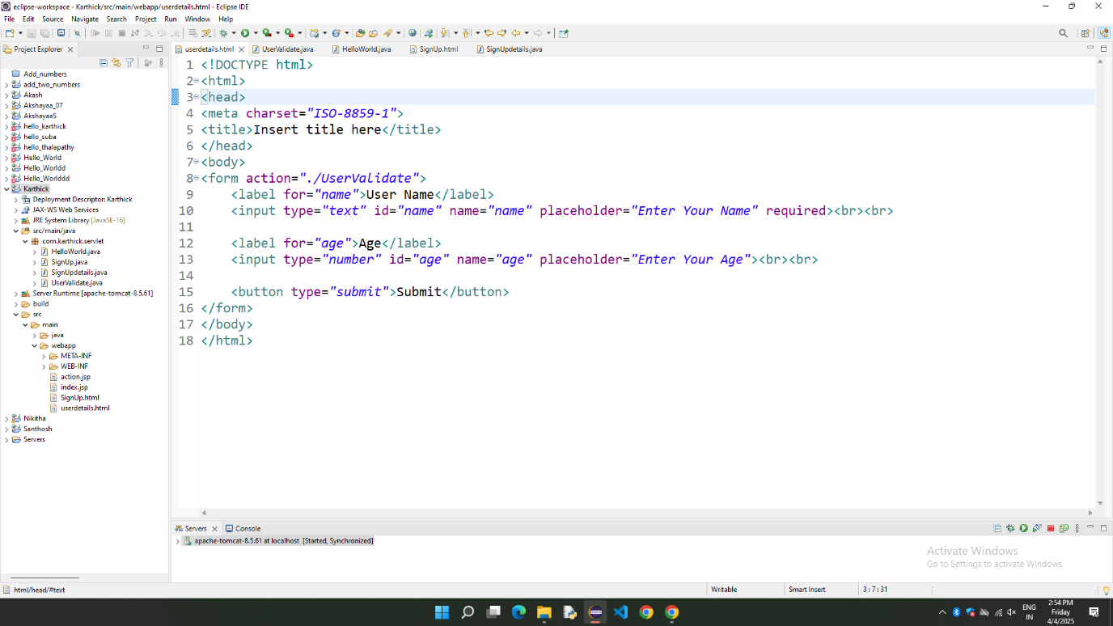
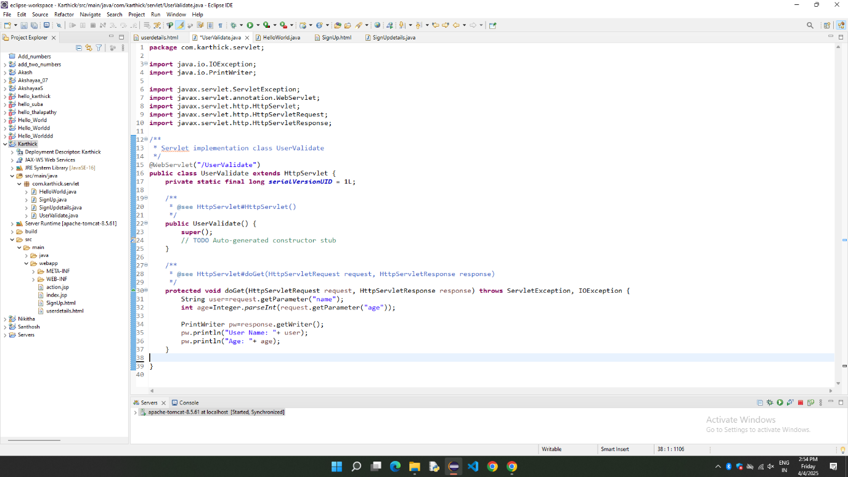

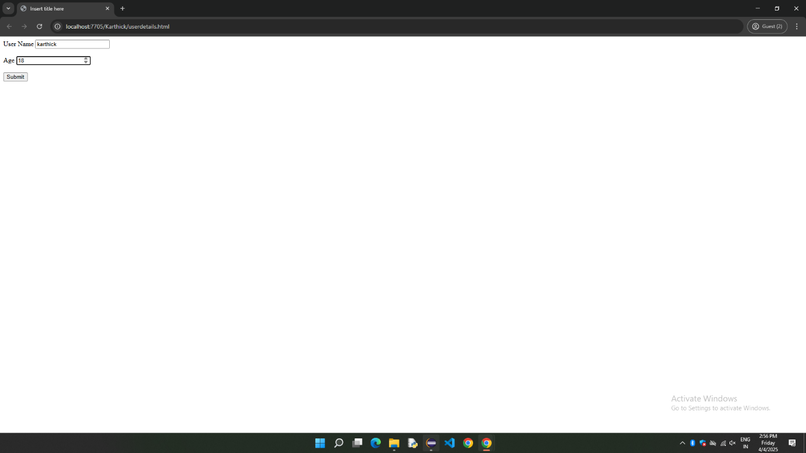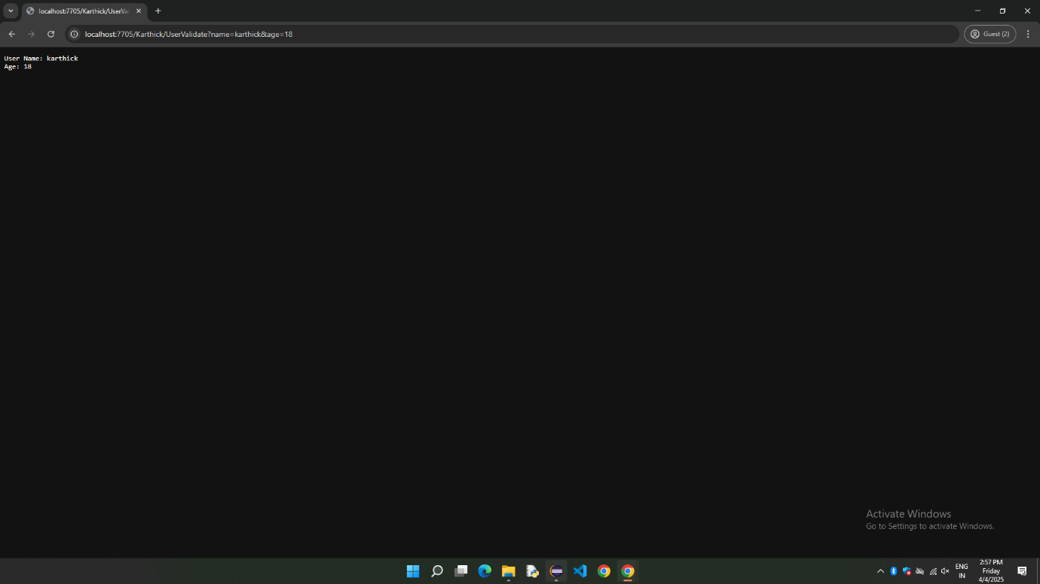

RESULT:
Thus, the web form is Implemented Successfully using html and Servlet.

